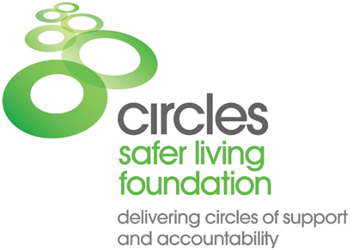

CORE MEMBER REFERRAL FORM

To enable us to assess the suitability of the proposed Core Member for a Circle, and select suitable volunteers, please complete this form as fully as possible and return with any relevant documentation to:
Safer Living Foundation, HMP Whatton, New Lane, Whatton, Nottingham, NG13 9FQ or e-mail slfhmpwhatton@justice.gov.uk
Please read the following instructions before completing the form:
- Please attach as much supporting documentation as possible to assist in the evaluation process.
- Please ensure the CM has signed the Consent Form.

Referring Project or Agency
Name of Project or Agency

Date of Referral

Name of Referrer

Position

Address

Telephone

E-mail

Proposed Core Member Personal Details
Name of Proposed CM

Date of Birth

Nationality – (White British etc...)

Prison Number

PNC Number

Religion

Sexuality

Referral Status
Status | Yes /No | Details  (e.g. start & end date, conditions etc.)
Remand

License

CRO

SHPO

Sex Offender Registration

Subject to MAPPA
(if yes specify level)

ROSHO

RM2000 Risk Category

Other (please specify)

Offence History
Details of Current / Previous Convictions
(please include dates, offence, court, and sentence)

Known Victim Target Group

Sex / Age Range

Relationship of victim(s) to CM

Is the victim (survivor) still living in the locality?

Treatment Programmes
Programme | Location | Date
Personal Circumstances (Support)
Where will the CM live?
(Please specify AP, hostel, home etc.)

If the current residence is an AP or hostel what follow on arrangements have been made?

Marital Status

Children
(please state details of CMs contact)

Other Support Agencies
(details of any community agencies, faith groups etc. who would support the CM)

Personal Circumstances (Other)
Does the CM have a learning disability?

Does the CM have any mental health issues?

Does the CM have a problem with substance misuse?

Is the CM disabled or have any mobility issues?

Any other special needs?

Agencies
Please give a contact, address, telephone number and e-mail.
MAPPA Contact

If in prison- Offender Supervisor

Offender Manager

MOSOVO Officer

Sex Offender Registration Police Station

Social Care / Health care Professional

Solicitor

Suitability
Why do you think the CM would benefit from a Circle?

Is the CM willing to take part in a Circle?
Does the CM give permission for his records, including Psychology reports, to be accessed for the purpose of setting up the circle?

(Sign and date please)

History of harm to staff or volunteers?

Documents Attached
Report | Yes/ No
Pre-sentence report

Psychologists report

Psychiatric report

SARNR

Prison treatment feedback report

SHPO

License Conditions

OASys
Other

